Unit 2: Nutrition throughout the Life Cycle Outline
What you will know by the end of the unit:
- The factors that determine why people eat the foods they do.
- The stages of the life cycle and nutritional needs characteristic of each stage.
- Nutritional concerns and challenges faced by people in each stage in the life cycle.
- Completing food labs applicable to this unit.
- Examples of entrepreneurship and careers associated with food and nutrition sciences.
- The different types of vegetarian regimes and reasons for being vegetarian.
- Concepts related to Social Science research.
- How to plan, conduct and summarize the results of an investigation into the availability of food products for various parts of the life cycle.
- Completing a Unit Culminating Activity: conducting a study to determine the eating habits practiced at a specific stage of the life cycle and creating an informative handout giving information about that stage.
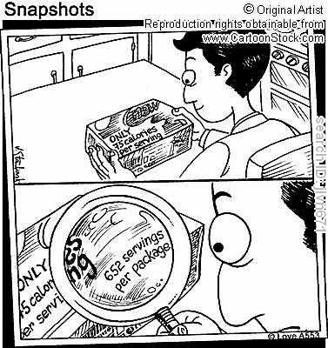

Assessment & Evaluation of Student Achievement
Task/Product | Tool | Purpose | Category of Achievement Chart
Case studies  T/L S 1 | Criterion- Referenced Checklist | Summative | Knowledge/Understanding  Application
Organizer chart for different life cycles  T/L S 3 | Anecdotal Comments | Formative | Knowledge/Understanding Thinking/Inquiry
Article Summary  T/L S 4 | Rubric | Summative | Thinking/Inquiry  Communication
Tasting Evaluation  T/L S 7 | Criterion- Referenced Checklist | Summative | Thinking/Inquiry  Communication  Application
Food lab  T/L S 9 | Rubric | Summative | Knowledge/Understanding Thinking/Inquiry  Application
Lifecycle Nutrition Fact Sheet  T/L S 10 | Rubric | Summative | Knowledge/Understanding Thinking/Inquiry  Application  Communication
Lifecycle Quiz  T/L S 1 | Pencil-and-paper quiz or Internet quiz | Diagnostic | Knowledge/ Understanding

Accommodations
• Allow students more time for completion of tasks
• Groups may be predetermined to meet the needs of all students.
• Record discussion notes, e.g., on overhead sheet, print on chart paper, etc.

