Lab 6: Success in Secondary School
Study Skills Brainstorming – GROUP WORK!
Create the mind map from below with a group of 3-4 people. Be prepared to present your ideas to the class!
Complete the diagram showing 10 different study skills or strategies that you can engage in to be successful at school.
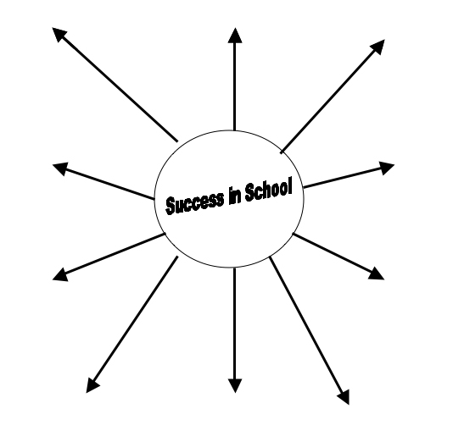
Activity 9: My Study Skills – Self Assessment

